Sakshi Patel

CPS 3320

Professor Robert Domanski

Project #2

March 25, 2021

**Write-up**

Date Code

A date in Python is not a data type of its own, but we can import a module named datetime to work with dates as date objects. Before we run the code for datetime format in Python, it is important that we import the Python date time modules.



This line tells the Python interpreter to import the date class from the datetime module in Python. We are not writing the code for this date functionality alas just importing it for our use.

So for my code I used datetime.datetime.today() code inside the print() statement to print the today's current date and time as output and code shown below.

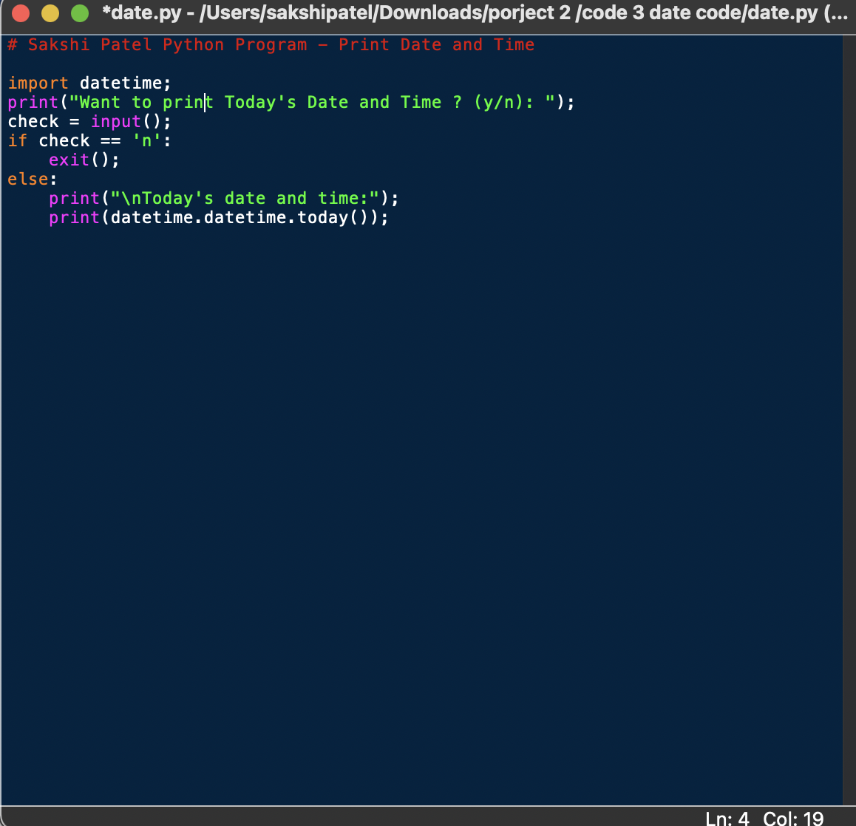

So when we run the program it will ask us if we want to print today's date and time. It gives you an option to say ‘y’ meaning yes and ‘n’ meaning no.

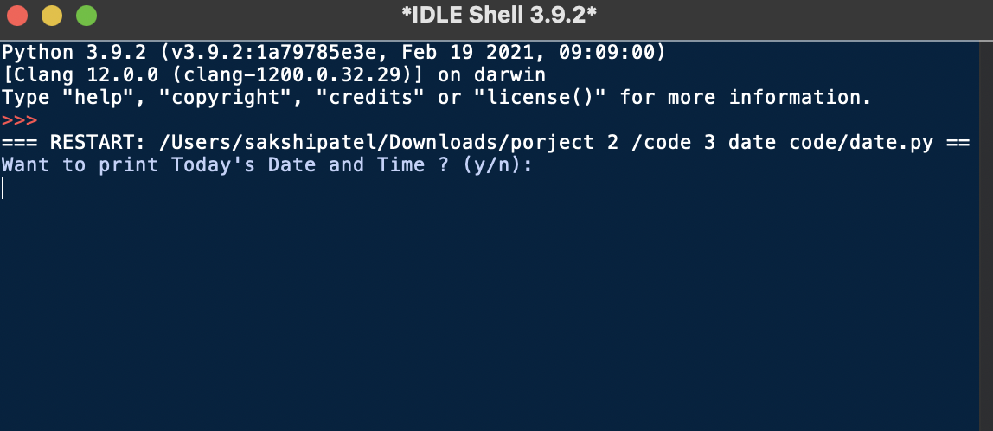

When you click on ‘y’ the output will be as shown below:

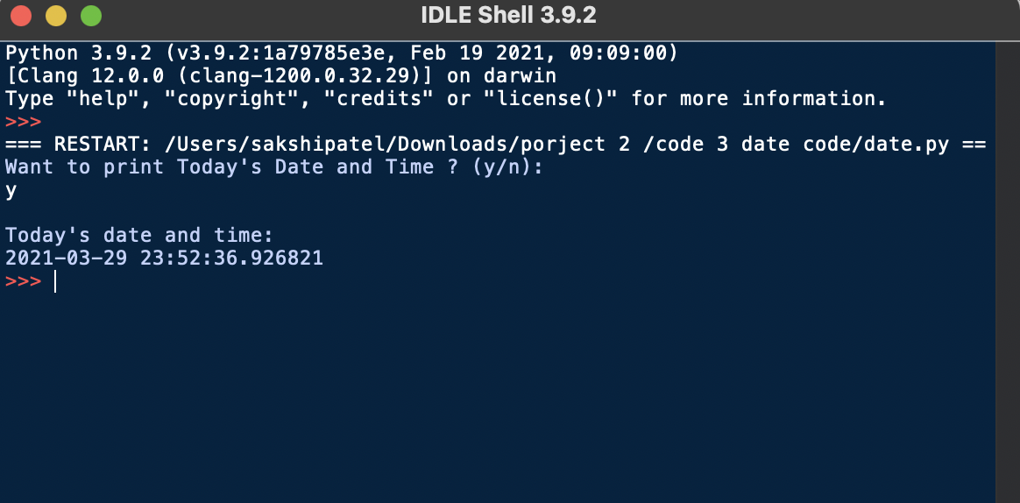

However when you click on ‘n’ it will kill the program.

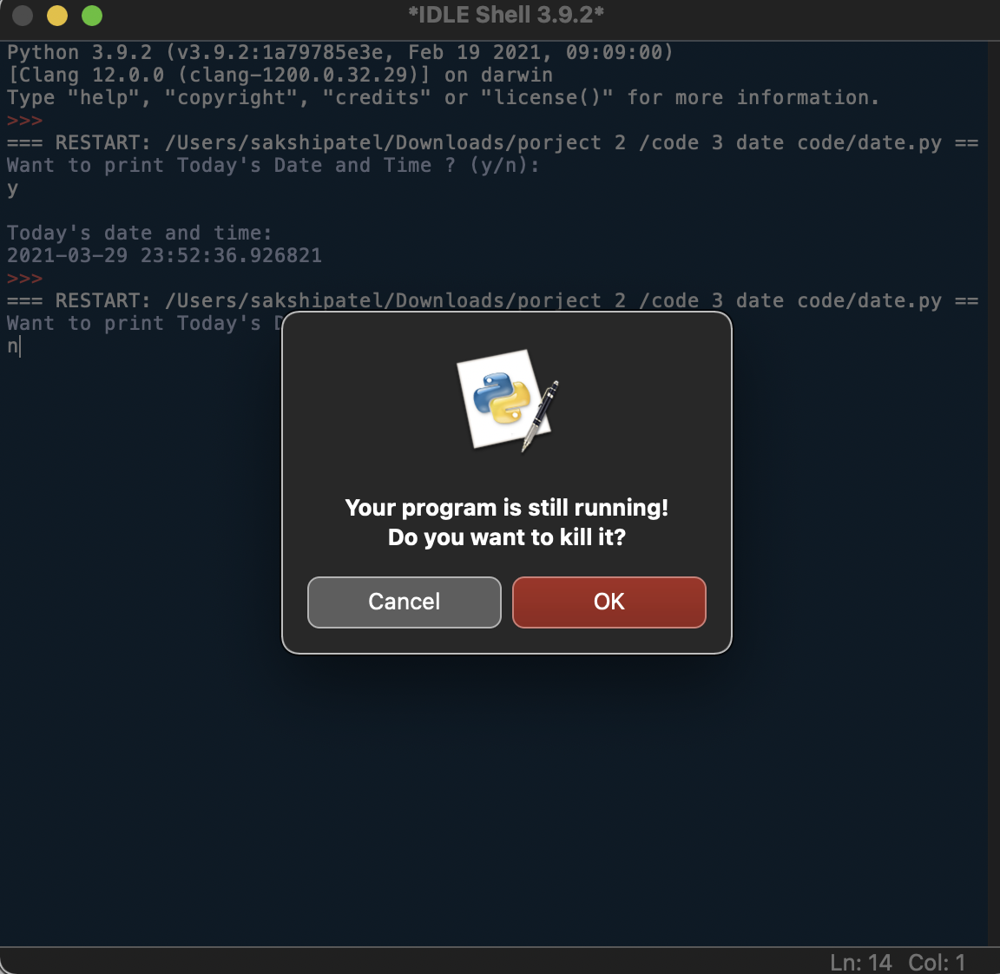

To conclude, I have successfully had my code working. After writing this code I learned a few uses of datetime.

Using datetime objects

* Importing datetime objects before executing the code is mandatory
* Using date.today function for printing individual date/month/year as well as indexing the day
* Using date.time object to get time in hours, minutes, seconds and milliseconds

Sources:

<https://www.python.org/dev/peps/pep-0321/>

<https://www.youtube.com/watch?v=RjMbCUpvIgw>